
67th ANNUAL GSMA CONFERENCE REGISTRATION (PER INDIVIDUAL) APRIL 23 – 26, 2026
Holiday Inn Gas South Arena 6310 Sugarloaf Pkwy, Duluth, GA 30097 (770) 476-2022
ROOM RESERVATIONS AND HOTEL FEES
Reservations should be made by no later than Wednesday, March 24, 2026.
Standard king $124/night + tax – Standard queen $124/night + tax
*Breakfast included with reservation (Up to 2 per room)
You may call or use the link to make your reservations: https://www.ihg.com/redirect?path=rates&brandCode=HI&localeCode=en&regionCode=1&hotelCode=ATldu&checkInDate=23&checkInMonthYear=032026&checkOutDate=26&checkOutMonthYear=032026&_PMID=99801505&GPC=GSM&cn=no&adjustMonth=false&showApp=true&monthIndex=00

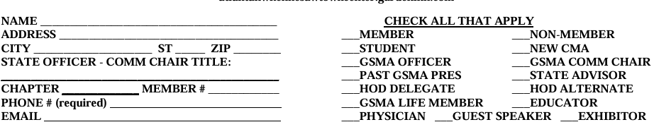

TOTAL PACKAGE REGISTRATION FEES – MUST BE POSTMARKED by March 24, 2026.

Full Registration (*price per person) – Includes all CEUs & meals (Breakfast only for those that reserve a room)
Number Total Amt
MEMBER / MEMBER SPOUSE / PHYSICIAN / STUDENT MEMBER / AND EXHIBITOR $200.00 _______ ________
NON-MEMBER / NON-MEMBER SPOUSE $250.00 _______ ________

PARTIAL REGISTRATION *price per person) - Includes CEUs & meals (Breakfast only for those that reserve a room)
MEMBER / MEMBER SPOUSE / PHYSICIAN / STUDENT MEMBER / AND EXHIBITOR $130.00 _______ ________
NON-MEMBER / NON-MEMBER SPOUSE $150.00 _______ ________
Indicate partial date that will be attended (circle the appropriate): Friday, April 24, 2026 or Saturday, April 25, 2026

LATE REGISTRATION (any postmark made after March 24, 2026) / *May register on-site to include late fees
MEMBER / MEMBER SPOUSE / PHYSICIAN / STUDENT MEMBER / AND EXHIBITOR $225.00 _______ ________
NON-MEMBER / NON-MEMBER SPOUSE $275.00 _______ ________

If you would like to purchase a meal only (not attending CEU sessions), please check the meal you plan to attend:

Check if attending Total
FRIDAY WELCOME LUNCH $40.00 ____________ ____________
FRIDAY DINNER $50.00 ____________ ____________
SATURDAY AWARDS LUNCH $40.00 ____________ ____________
SATURDAY DINNER $50.00 ____________ ____________
Total: ____________

Total Enclosed: ____________

Please list any food allergies: _______________________________________________________________

An ADMINISTRATIVE fee of $25.00 per person will be assessed for any CANCELLATION made after 5 pm on 4/1/26.
NO REFUNDS will be given after 5 pm on April 10, 2026.
A $40.00 fee for any check returned due to INSUFFICIENT FUNDS will be assessed.
If registration is not received, you will be expected to pay late registration at the door. No exceptions.

***The Georgia Society of Medical Assistants Preconference Executive Board meeting will be held on Thursday, April 23, 2026, at 8 pm in the Magnolia B meeting area of the hotel. The Post Conference meeting will be held at 10am Sunday April 26, 2026 in the same area.

In case of emergency, please indicate your person of contact:
Name: ______________________________ Relationship: ______________________________
Phone: _____________________________

Make checks or Money Order payment to: Georgia Society of Medical Assistants, Inc. 2026 Annual Conference

Mail Registration to: Christina McRee, CMA (AAMA), A.S.
6627 Barker Station Walk
Sugar Hill, Ga 30518
For Inquiries: cmcree@laniertech.edu

Postmarked: ___________________
Received: ___________________

